Method: Face Frame Full Dado

Face Frame (3/4 thick)
Stiles 2”
Bottom Rail 2”
Top Rail Base 2”
Top Rail Wall / Tall 3”
Return End Stile Base 3”
Return End Stile Wall 2”
Extended End Stile Base 3 ¾”
Extended End Stile Wall 2 ¾”

To modify Frame sizes:
Click Libraries
Select FACE FRAME
Click the Construction Button
Select the FACE Category

To modify Ret/Ext End Stiles
Click Libraries
Select FACE FRAME
Click the Construction Button
Select the ENDS Category

SCRIBE
Finished End Scribe – 0
Unfinished End Scribe – ½”

To modify Scribe
Click Libraries
Select FACE FRAME
Click the Construction Button
Select the CASE Category

Material Templates
3/4 …
1/2 …

www.mozaiksoftware.com

Optimized for flat panel processing
This construction method is for Face Frame construction with full dados. Bottoms & Tops dado into the ends, partitions dado into the Top & Bottom. Fixed Shelves dado into the verticals. Stop dados are used for all parts that are not full depth.
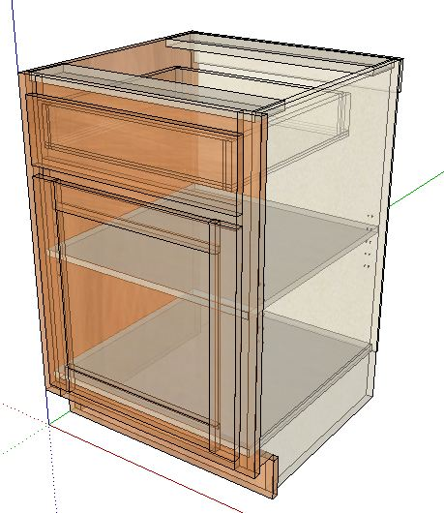
Part Operations.
Case Parts
Dado Depths.
Bottom / Top into End Panels ¼”
Fixed Shelves ¼”
Partitions into Bottom/Top ¼”
Back into End panels ¼”
Adjustable Shelves.
3/16” clearance
Face Frames
Butt Joint construction (Pocket Screws-recommended)
Machining Specifications.
Nested Based Router Setup.
Tool #1 3/8 compression spiral (Outline tool)
Tool #2 3/8 down shear bit (dados/pockets)
Tool #3 1/4 down shear bit (back dados)
Tool #4 1/2 down shear bit (3/4 dados/pockets)
Drills 5mm
(If no boring block, place a 5mm bit into Tool #5)

Machines with no Tool Changer.
Primary Tool 1/4 compression spiral.
(Adjustable shelf holes will be ¼”.)

Page 2 www.mozaiksoftware.com

